**BANKING MANAGEMENT SYSTEM**

iiiiiiiiiiiiiiiiiiiiiiiiiiiiiiiiiiiiiiiiiiiiiiiiiiiiiiiiiiii

Summer InternshipiProjecti

Submitted in partial fulfillment of the requirements

Foritheidegreeiofi

MasteriofiComputeriApplication

By:

AKHIL PANDEY(22MCA040)

GuidediBy DR.IRAJAN DATT

IMASTERiOFiCOMPUTERiAPPLICATION

DEPARTMENTiOFiCOMPUTERiSCIENCEi&iENGINEERING



DEPARTMENTiOFiCOMPUTERiSCIENCEi&iENGINEERING

Ahmedabadi382481

**CERTIFICATE**

ThisiisitoicertifyithatitheiSummer Internship Project entitled “Banking Management System” submitted by Pandey Akhilkumar Rajeshkumar (22MCA040) towards the partial fulfillment of the requirements for the degree of Master of Computer Application of Nirma University is the record of the work carried out by him/her/them under my supervision and guidance. In my opinion, the submitted work has reached the level required for being accepted for examination.

 

Rajan Datt Dr. Madhuri Bhavsar

Assistant Professor, MCA Department Head of Department

Computer Science & Engg. Dept. Computer Science & Engg. Dept.

Institute of Technology Institute of Technology

Nirma University Nirma University

Ahmedabad Ahmedabad

**SUMMER INTERNSHIP CERTIFICATE**

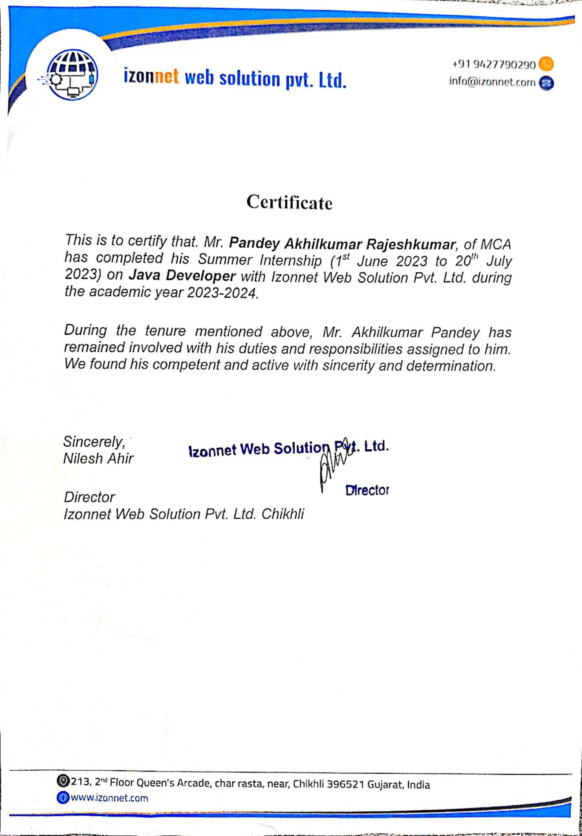

iiiiiiiiiiiiiiiiiiiiiiiiiiiiiiiiiiiiiiiiiiiiiiiiiiiiiiiiiiiiiiiiiiiiiiiiiiiiiiiiiiiiiiiii

**INDEX**

|  |  |
| --- | --- |
| Sr. no | Title |
| 1. | Project Scope and Description |
| 2. | Tools and Technologies |
| 3. | Diagrams |
| 4. | Screen Shots of the project |
| 5. | Test Report |
| 6. | Conclusion |
| 7. | Bibliography |

* **Project Scope and Description**

The Banking Management System is a comprehensive software solution developed in Java using JSP (Java Server Pages), Servlets, and other technologies. The primary objective of this system is to provide an efficient and secure platform for managing various banking operations and services. It facilitates seamless interactions between customers, employees, and administrators, ensuring a user-friendly experience while maintaining the utmost security of sensitive financial data.

* **Scope**

The scope of the Banking Management System encompasses the following key functionalities:

**a). Customer Registration and Authentication:**

New customers can register and create their accounts with the necessary personal information.

Existing customers can log in securely using authentication mechanisms.

**b). Account Management:**

Customers can open different types of accounts, such as Savings, Current, and Fixed Deposit accounts.

The system allows customers to view their account balances, transaction history, and account details.

**c). Fund Transfer:**

Customers can transfer funds between their own accounts or to other registered users within the bank.

Appropriate security measures, such as transaction authorization, are implemented to ensure secure transfers.

**d). Credit Management:**

Customers can apply for various types of loans, and the system facilitates loan processing and approval.

It allows customers to check their credit eligibility and credit limit.

**e). User Management:**

Bank users can access the system with their unique credentials to perform various tasks.

Employees can view customer information, process transactions, and handle account-related activities.

**f). Administrative Controls:**

Administrators have access to advanced functionalities, including managing employee accounts, adding/removing services, and overseeing system security.

* **Technology Stack:**

**Front-End:** JSP (Java Server Pages), HTML, CSS, JavaScript

**Back-End:** Java, Servlets, JDBC (Java Database Connectivity)

**Database:** MySQL or any other suitable RDBMS (Relational Database Management System)

**Application Server:** Apache Tomcat or any compatible server

Project Deliverables:

Complete source code of the Banking Management System

User documentation with instructions for installation and usage

Test cases and test results to ensure system functionality and reliability.

Any additional tools or utilities required for the smooth operation of the system.

ACCOUNT DETAIL

|  |  |  |  |
| --- | --- | --- | --- |
| Name | Data_Type | Field Length | Constraints |
| acc_no | Int | 7 | Primary Key |
| uname | Varchar | 45 | NOT NULL |
| acc_type | Varchar | 45 | NOT NULL |
| details | Varchar | 45 | NOT NULL |

FUND TRANSFER DETAILS

|  |  |  |  |
| --- | --- | --- | --- |
| Name | Data_Type | Field Length | Constraints |
| id | Int | 7 | Primary Key |
| uname | Varchar | 45 | NOT NULL |
| acc_no | Varchar | 45 | NOT NULL |
| dest_acc | Varchar | 45 | NOT NULL |
| amt | Int | 10 | NOT NULL |
| details | Varchar | 45 | NOT NULL |
| time1 | Timestamp | 45 | NOT NULL |

TRANSACTION DETAILS

|  |  |  |  |
| --- | --- | --- | --- |
| Name | Data_Type | Field Length | Constraints |
| uname | Varchar | 45 | NOT NULL |
| acc_no | Int | 7 | Primary Key |
| operation | Varchar | 45 | NOT NULL |
| amt | Int | 10 | NOT NULL |
| balance | Int | 20 | NOT NULL |
| time1 | Timestamp |  | NOT NULL |
| isnew | Varchar | 3 | NOT NULL |

USER DETAILS

|  |  |  |  |
| --- | --- | --- | --- |
| Name | Data_Type | Field Length | Constraints |
| id | Int | 7 | Primary Key |
| uname | Varchar | 15 | NOT NULL |
| upass | Varchar | 8 | NOT NULL |
| sec_question | Varchar | 45 | NOT NULL |
| answer | Varchar | 45 | NOT NULL |
| address | Varchar | 50 | NOT NULL |
| email | Email | 45 | NOT NULL |
| mobile | Long | 10 | NOT NULL |
|  |  |  |  |

USE CASE DIAGRAM

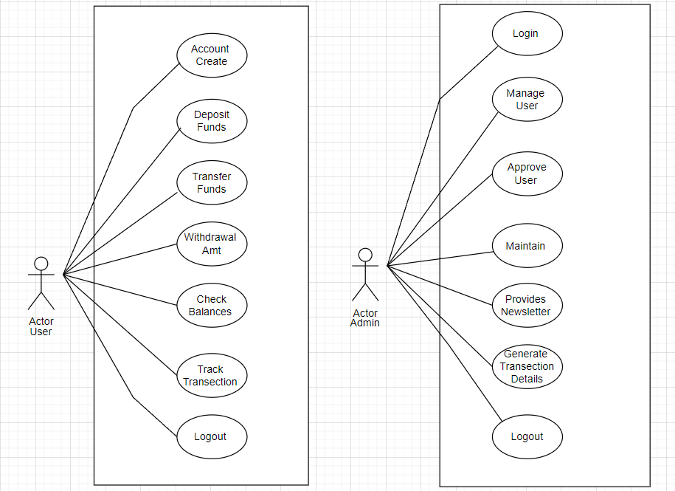

SYSTEM FLOW DIAGRAM

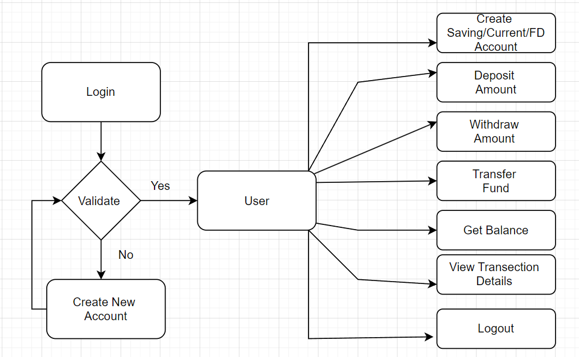

* SCREEN-SHORT

**Create New Account**

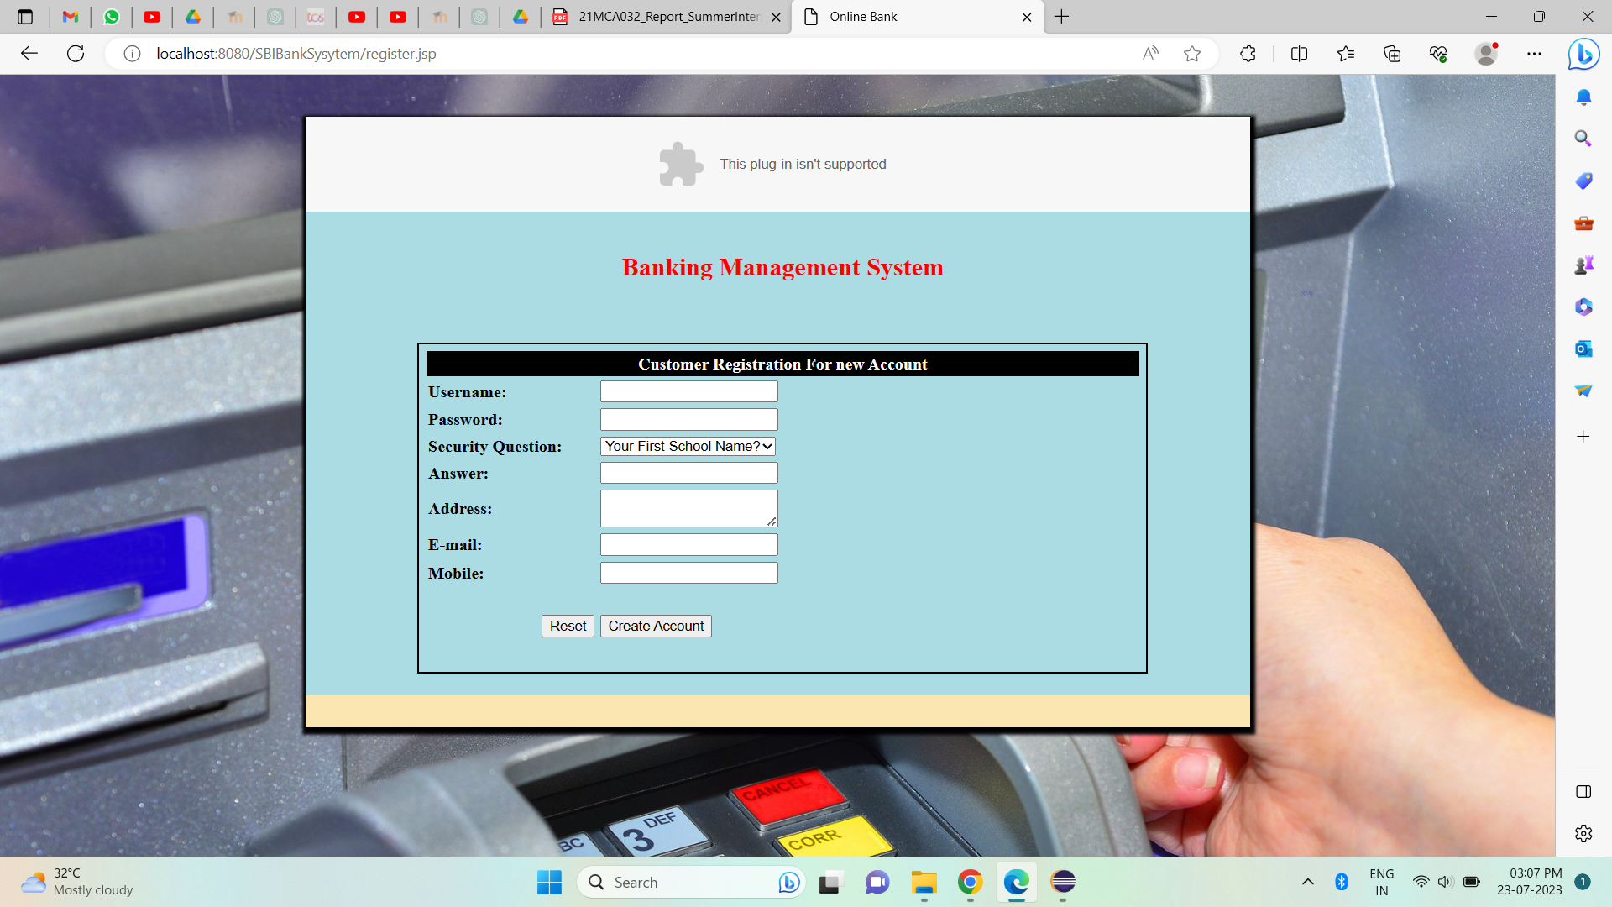

**Login Page**

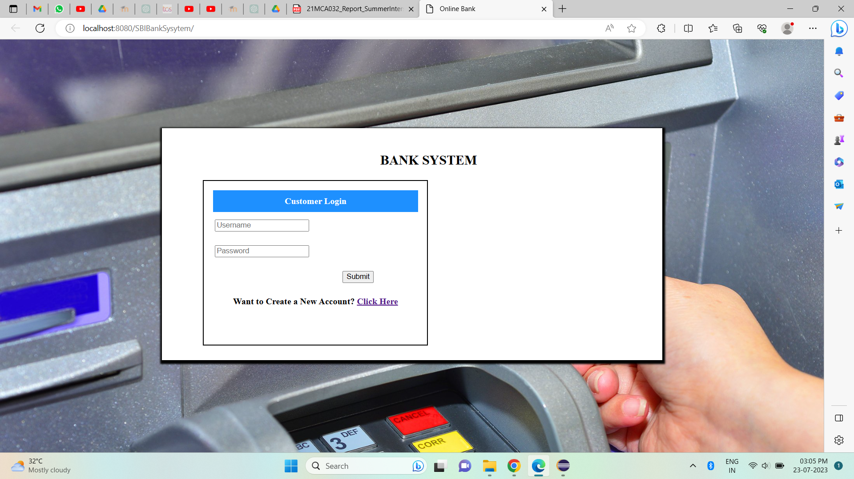

**Welcome Home Page**

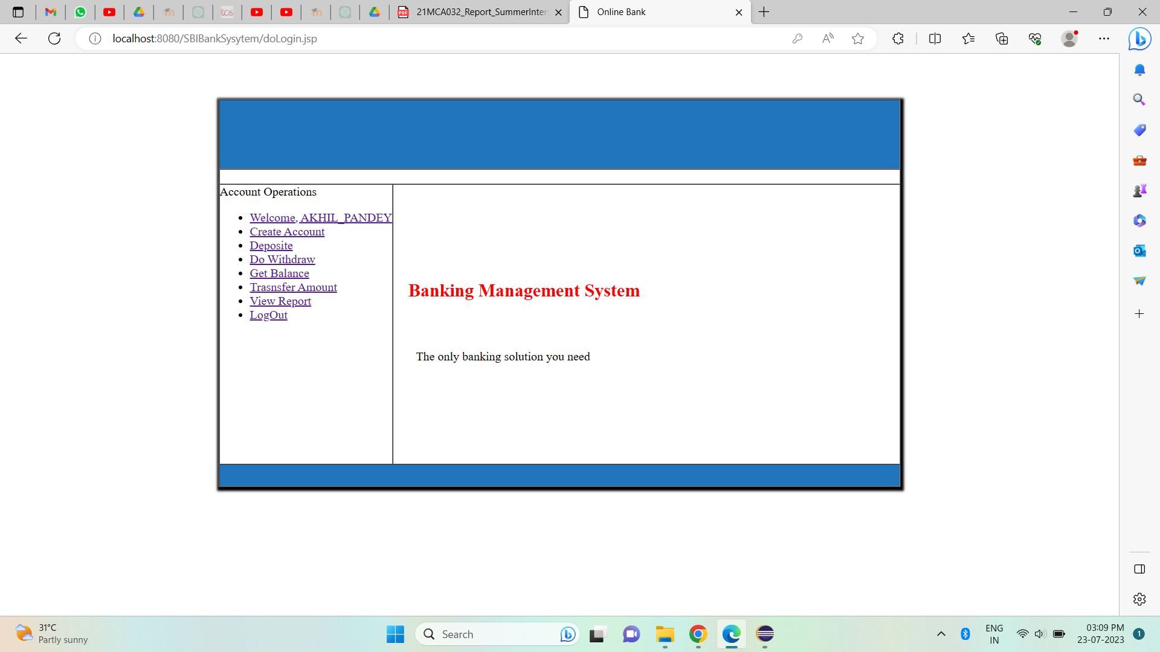

**Create a Saving/Current/Student Account**

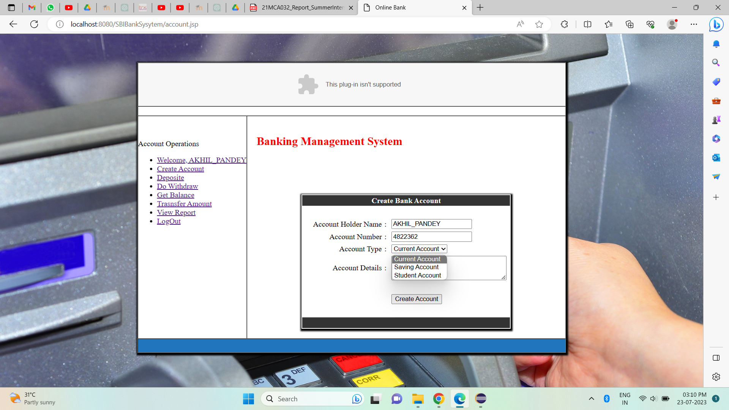

**Deposit Amount**

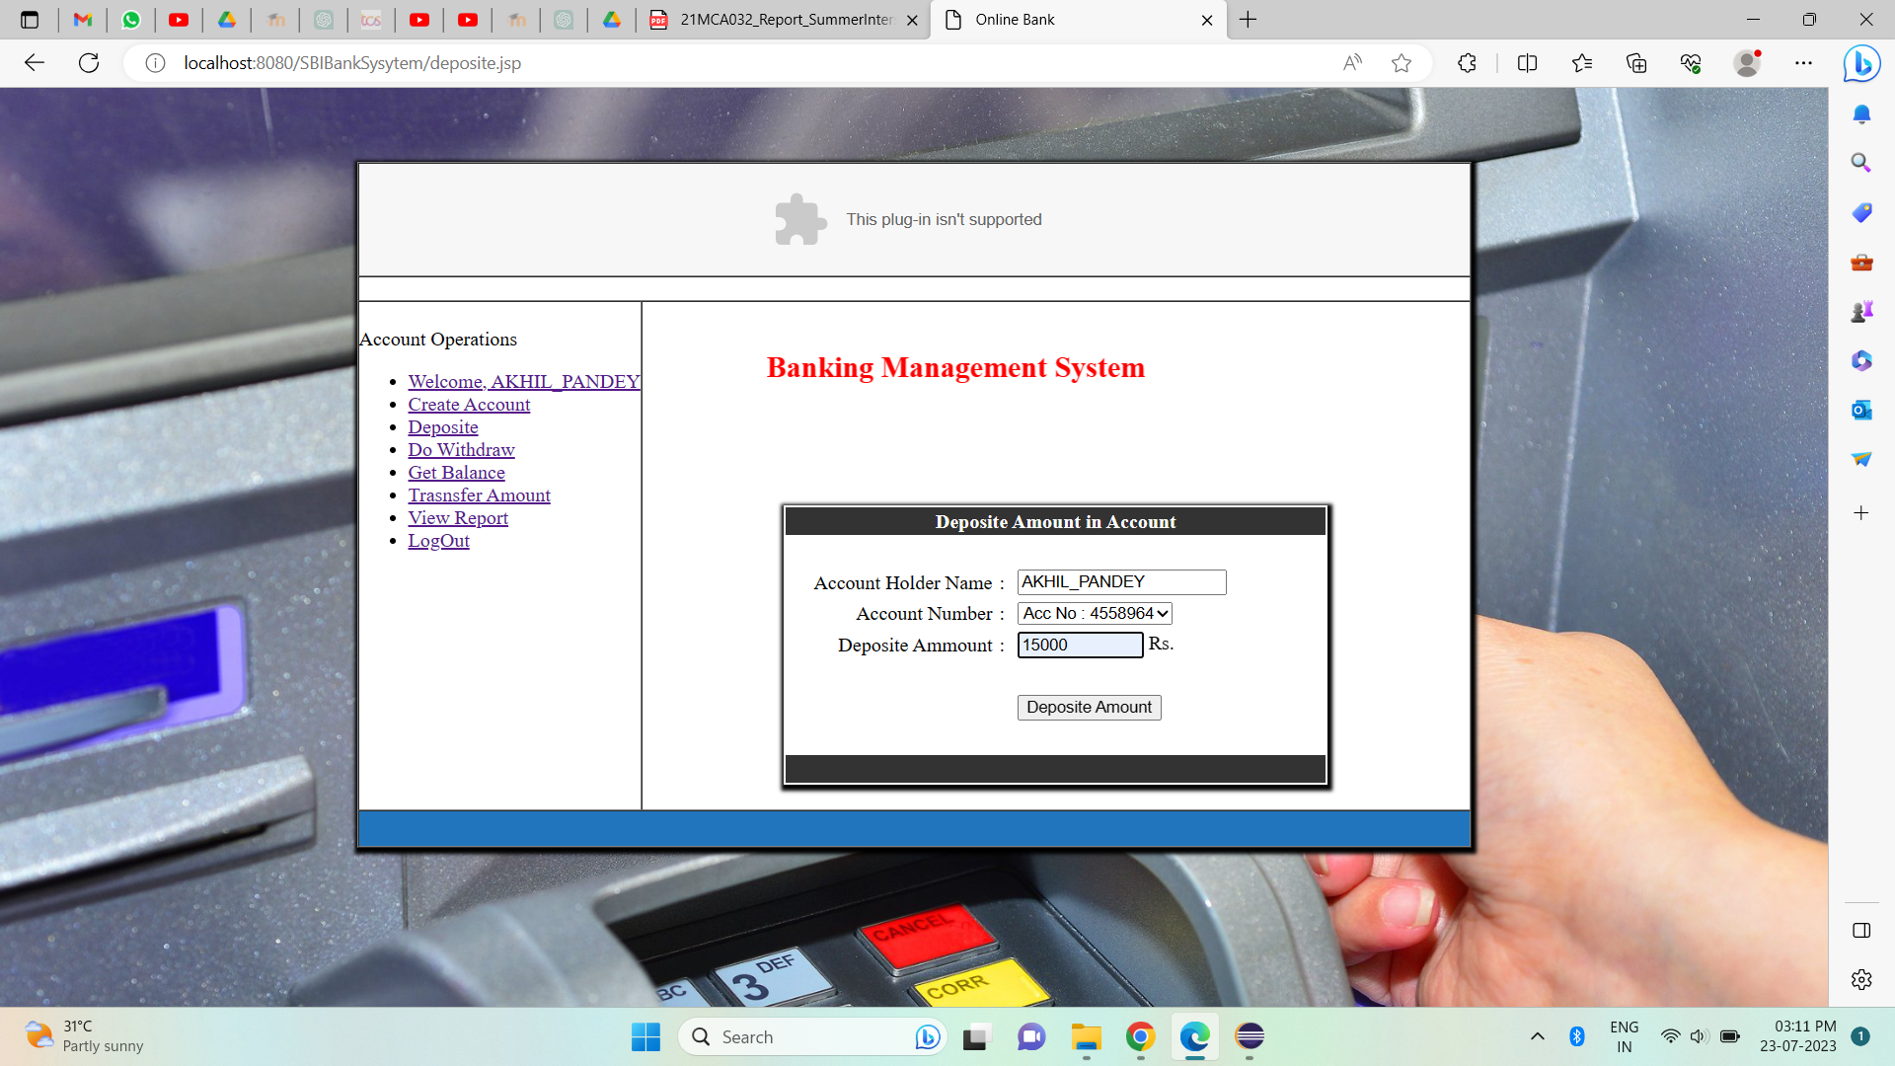

**Withdraw Amount**

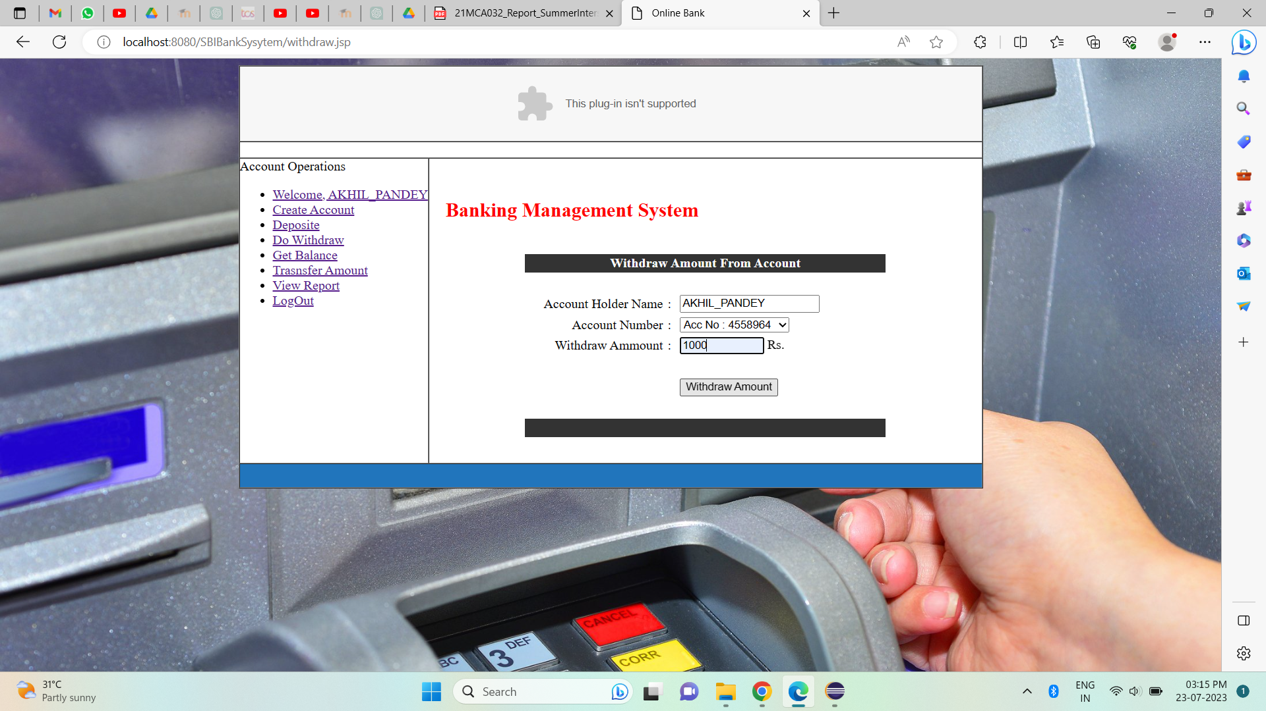

**Transfer Amount**

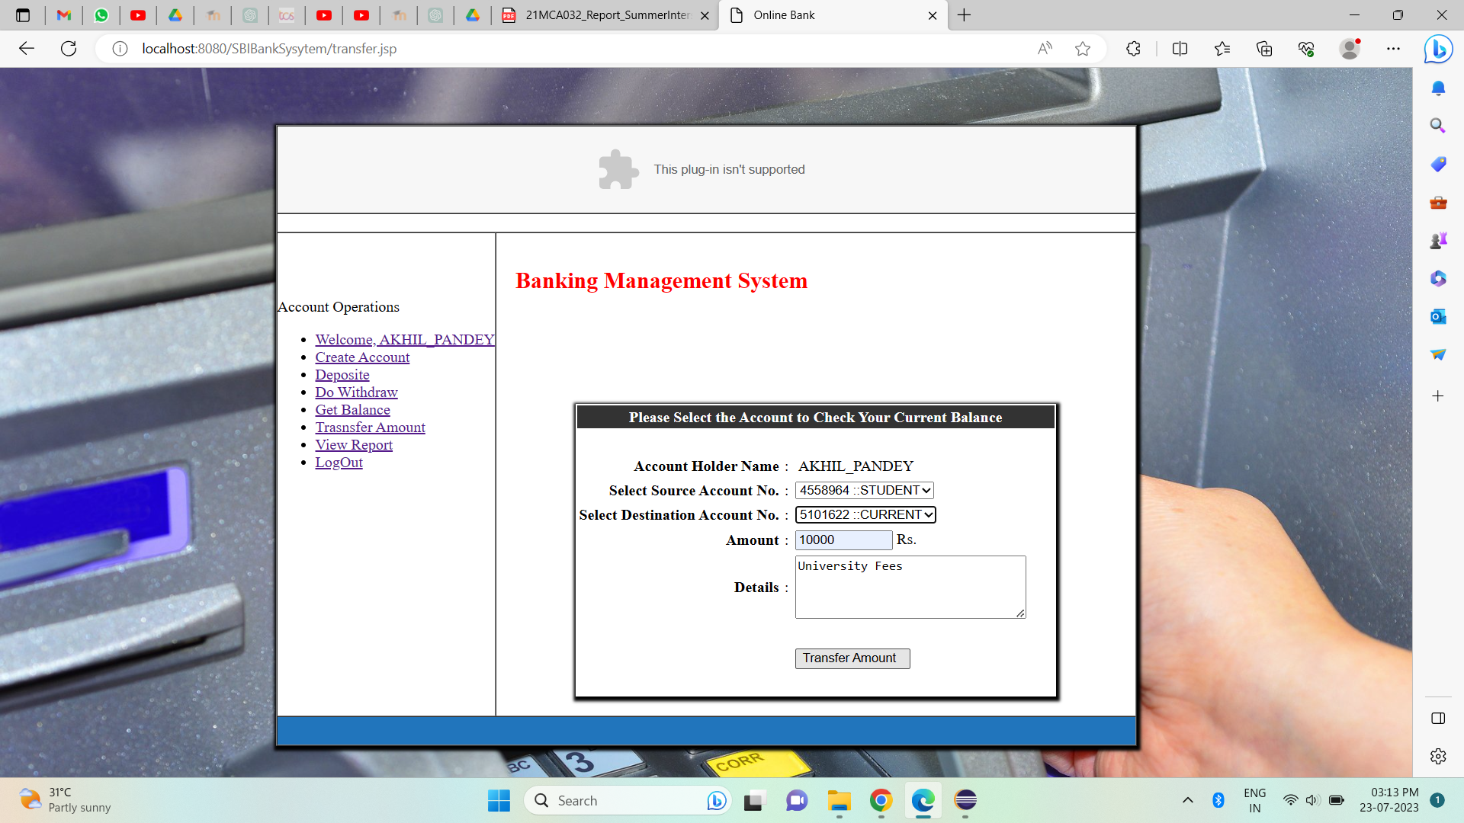

**Check Balance**

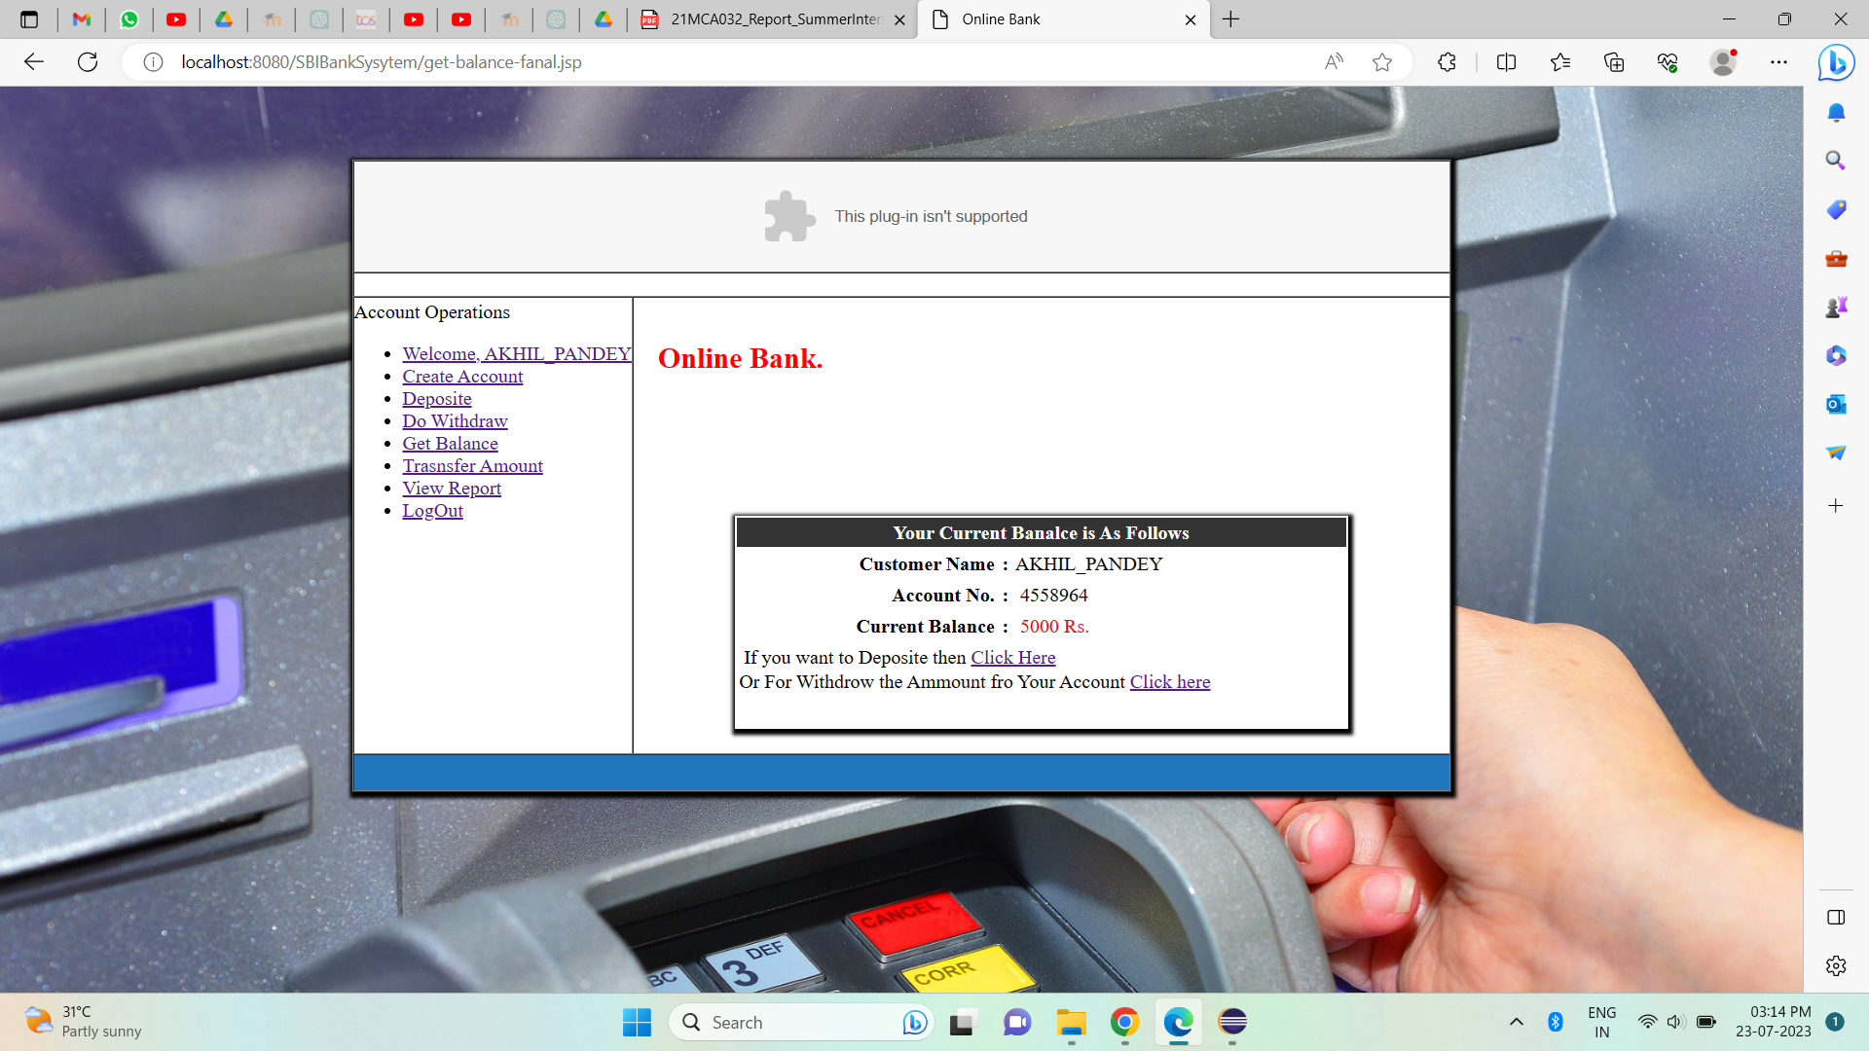

**View Transaction Report**

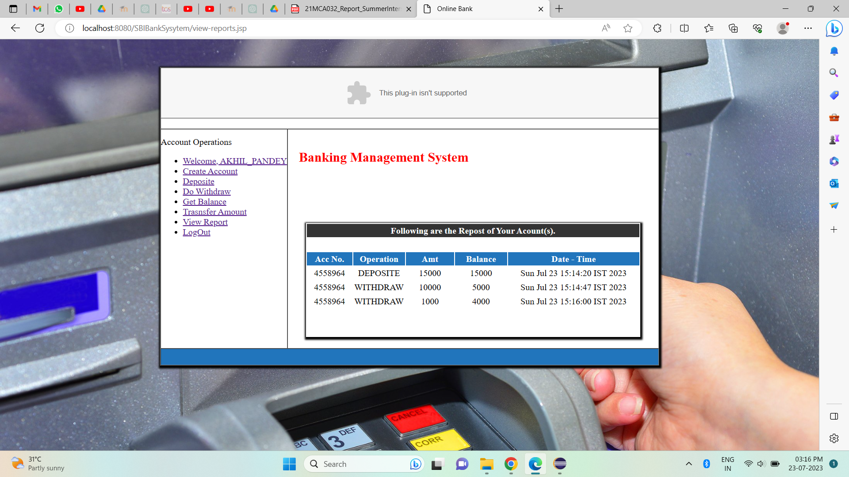

**DATABASE**

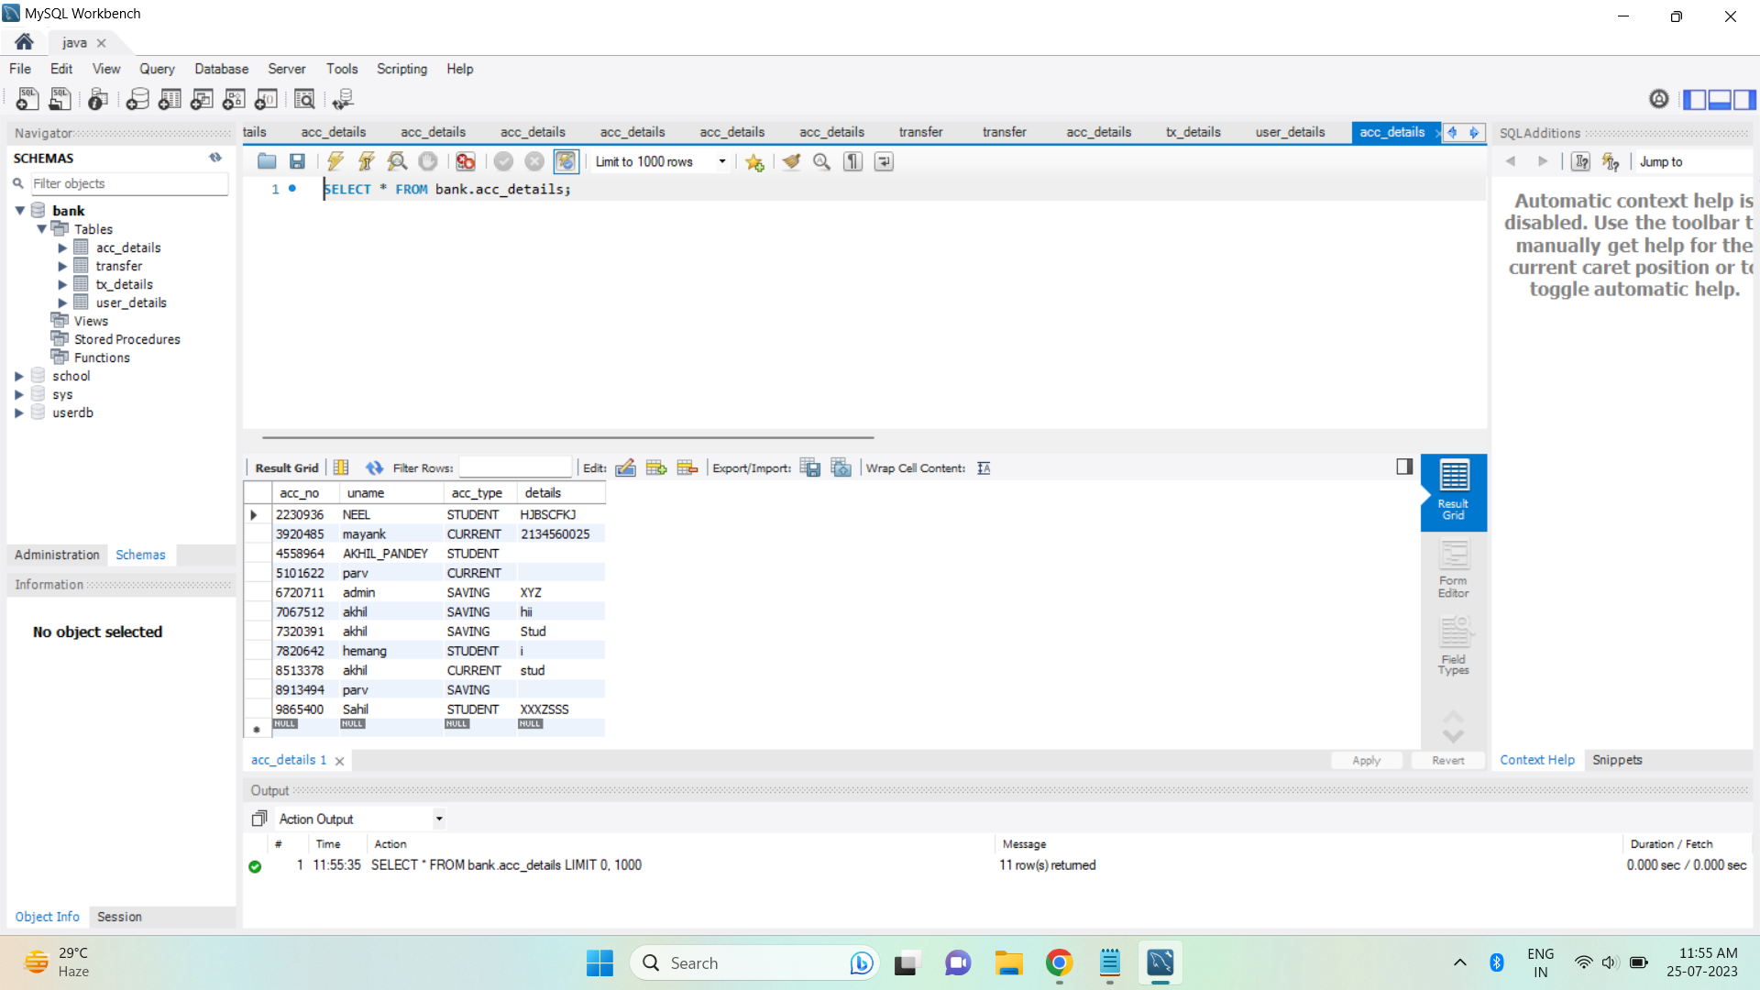

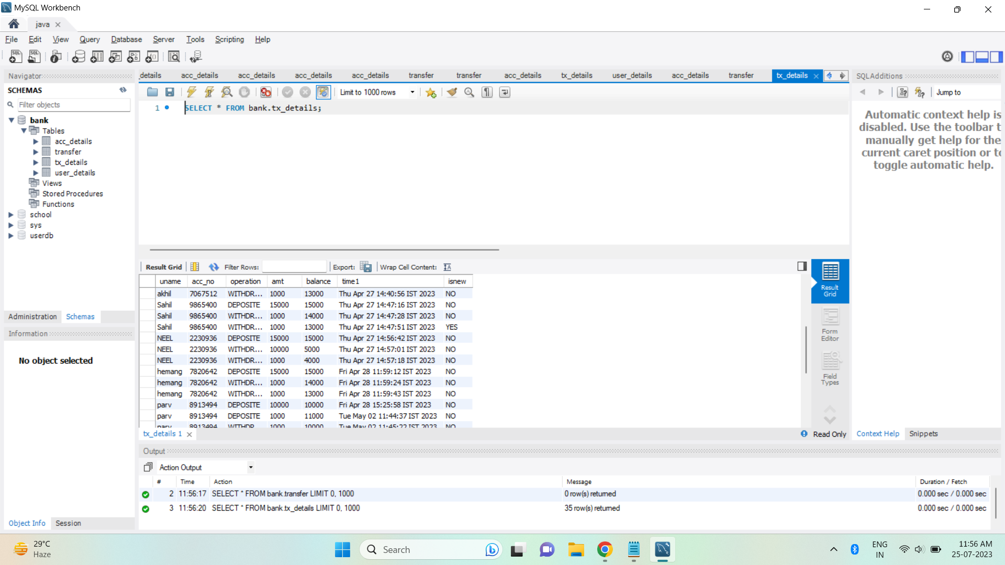

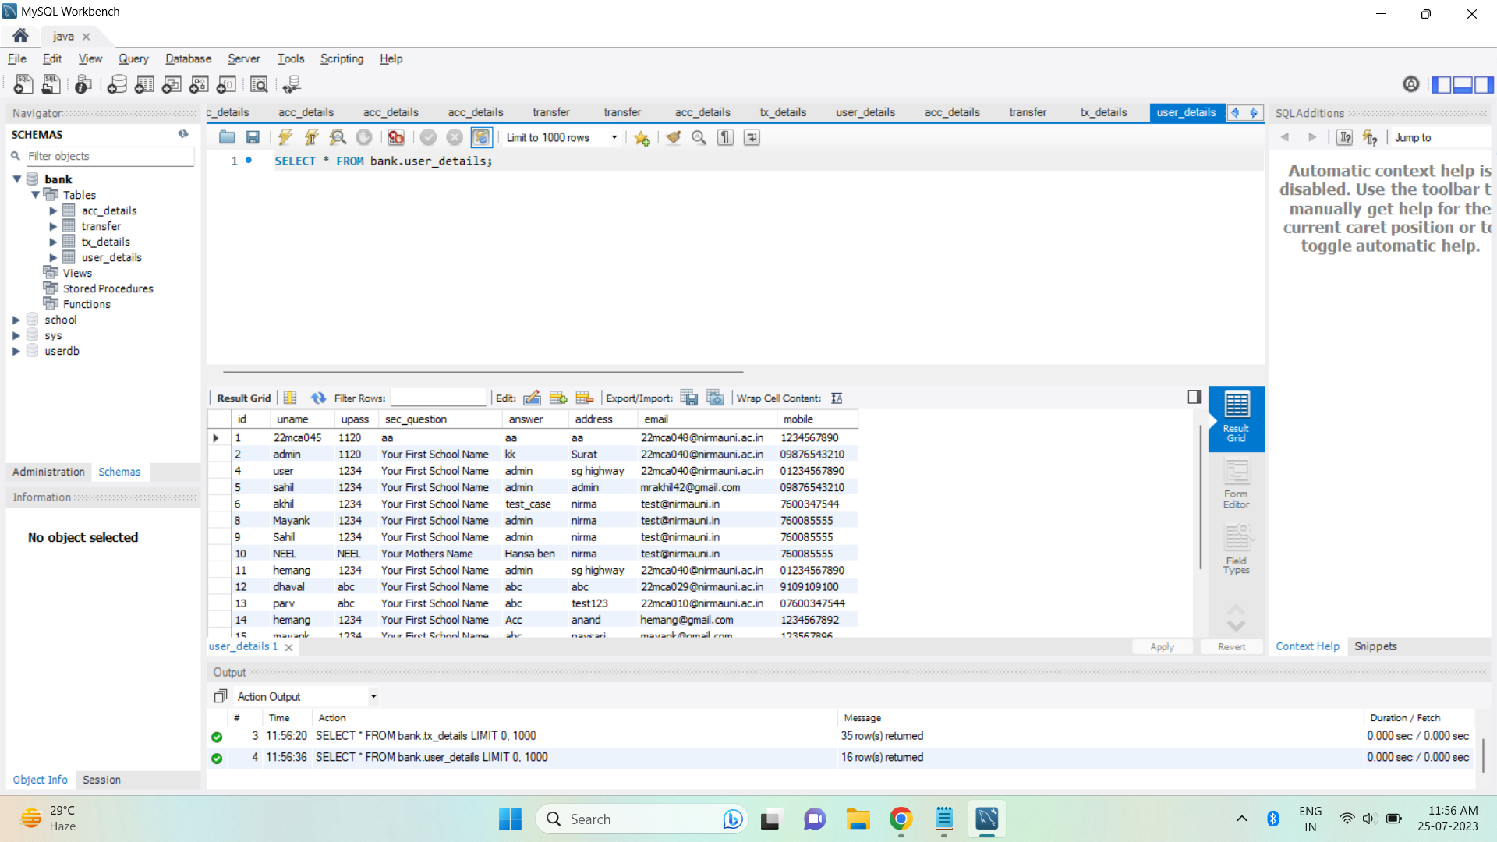

**Test Case Report: Banking Management System**

**Test Case 1: Customer Registration and Authentication**

Test Case ID: TC001

Test Case Description: Verify that a new customer can register successfully and log in securely.

Test Steps:

1. Click on the "Register" button on the login page.
2. Fill in the required fields with valid customer information (e.g., name, email, address, etc.).
3. Set a secure password that meets the system's password policy.
4. Click on the "Register" button to create the account.
5. Verify that the customer is redirected to the login page after successful registration.
6. Enter the registered username and password.
7. Click on the "Login" button.
8. Verify that the customer is successfully logged into the system and is redirected to the dashboard.
9. Expected Result: The new customer should be able to register successfully and log in without any errors.

Test Case Status: Passed

**Test Case 2: Account Management**

Test Case ID: TC002

Test Case Description: Verify that customers can open different types of accounts and view their account details.

Test Steps:

1. Log in to the system using valid customer credentials.
2. Click on the "Open Account" option in the dashboard.
3. Select "Savings Account" as the account type.
4. Fill in the necessary details and click on the "Submit" button.
5. Verify that the savings account is created successfully.
6. Repeat steps 2 to 5 for "Current Account" and "Fixed Deposit Account."
7. Go to the "My Accounts" section and click on the "View Details" option for each account.
8. Verify that the account details, including account balance, transaction history, and account type, are displayed correctly.
9. Expected Result: Customers should be able to open different types of accounts and view their account details without any issues.

Test Case Status: Passed

**Test Case 3: Fund Transfer**

Test Case ID: TC003

Test Case Description: Verify that customers can transfer funds between their accounts and to other registered users.

Test Steps:

1. Log in to the system using valid customer credentials.
2. Click on the "Transfer Funds" option in the dashboard.
3. Select "Transfer to Own Account" and choose a source and destination account.
4. Enter the transfer amount and click on the "Transfer" button.
5. Verify that the funds are transferred successfully, and the account balance is updated accordingly.
6. Repeat steps 2 to 4 for "Transfer to Other User" using a registered user's account.
7. Verify that the transfer is successful and reflects in the recipient's account.
8. Expected Result: Customers should be able to transfer funds between their accounts and to other registered users without any errors.

Test Case Status: Passed

**Test Case 4: Credit Management**

Test Case ID: TC004

Test Case Description: Verify that customers can apply for loans and check their credit eligibility.

Test Steps:

1. Log in to the system using valid customer credentials.
2. Click on the "Apply for Loan" option in the dashboard.
3. Choose a loan type (e.g., Personal Loan, Home Loan) and enter the loan amount.
4. Click on the "Submit" button to apply for the loan.
5. Verify that the loan application is processed and forwarded for approval.
6. Go to the "Check Credit Eligibility" option in the dashboard.
7. Verify that the system displays the customer's credit score and eligibility status.
8. Expected Result: Customers should be able to apply for loans and check their credit eligibility without any issues.

Test Case Status: Passed

**Test Case 5: User Management**

Test Case ID: TC005

Test Case Description: Verify that bank users can access the system with their credentials and perform authorized tasks.

Test Steps:

Log in to the system using valid employee credentials.

Verify that the employee is redirected to the employee dashboard.

Check if the employee can view customer information and process transactions.

Log in to the system using valid administrator credentials.

Verify that the administrator is redirected to the admin dashboard.

Check if the administrator can manage employee accounts and oversee system security.

Expected Result: Bank users should be able to log in and perform authorized tasks based on their roles (employee or administrator).

Test Case Status: Passed

**Test Case 6: Administrative Controls**

Test Case ID: TC006

Test Case Description: Verify that administrators can perform advanced functionalities and manage system settings.

Test Steps:

Log in to the system using valid administrator credentials.

Go to the "Employee Management" section in the admin dashboard.

Add a new employee account with necessary details.

Verify that the new employee account is created successfully.

Go to the "Services Management" section in the admin dashboard.

Add a new banking service to the system.

Verify that the new service is added to the available services.

Expected Result: Administrators should be able to manage employee accounts, add/remove services, and perform other administrative tasks without any issues.

Test Case Status: Passed

* **Conclusion:**

The Banking Management System developed in Java using JSP and other related technologies aims to streamline banking operations and enhance customer experience. It provides a secure, efficient, and user-friendly platform for customers, employees, and administrators to carry out their tasks effectively. By leveraging the power of technology, the system contributes to the growth and success of the bank by ensuring optimal management of financial services.

+

* **Bibliography**
* <https://www.javatpoint.com/servlet-api>
* <https://www.javatpoint.com/requestdispatcher-in-servlet>
* <https://stackoverflow.com/>
* <https://javapipe.com/blog/tomcat-application-server/>
* <https://www.coursera.org/learn>

iiiiiiiiiiiiiiiiiiiiiiiiiiiiiiiiiiiiiiiiiiiiiiiiiiiiiiiiiiiiiiiiiiiiiiiiiiiiiiiiiiiiii